### **Lab Exercise 6- Create POD in Kubernetes**

### **Objective:**

* Understand the basic structure and syntax of a Kubernetes Pod definition file (YAML).
* Learn to create, inspect, and delete a Pod in a Kubernetes cluster.

### **Prerequisites**

* Kubernetes Cluster: You need a running Kubernetes cluster. You can set up a local cluster using tools like Minikube or kind, or use a cloud-based Kubernetes service.
* kubectl: Install and configure kubectl to interact with your Kubernetes cluster.
* Basic Knowledge of YAML: Familiarity with YAML format will be helpful as Kubernetes resource definitions are written in YAML.

### **Step-by-Step Guide**

**Step 1: Create a YAML File for the Pod**

We'll create a Pod configuration file named **pod-example.yaml**

apiVersion: v1 # The version of the Kubernetes API to use for this object.

kind: Pod # The type of Kubernetes object. Here it's a Pod.

metadata: # Metadata about the Pod, such as its name and labels.

name: my-pod # The name of the Pod. Must be unique within a namespace.

labels: # Labels are key-value pairs to categorize and organize Pods.

app: my-app # Label to categorize this Pod as part of 'my-app'.

spec: # The specification for the Pod, detailing its containers and other settings.

containers: # List of containers that will run in this Pod.

- name: my-container # The name of the container. Must be unique within the Pod.

image: nginx:latest # The Docker image to use for this container. Here, it's the latest version of Nginx.

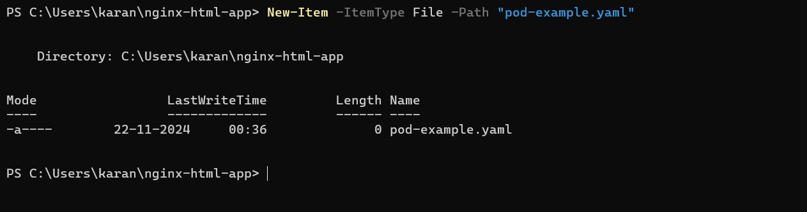

**Explanation of the YAML File**

* apiVersion: Specifies the version of the Kubernetes API to use. For Pods, it's typically v1.
* kind: The type of object being created. Here it's a Pod.
* metadata: Provides metadata about the object, including name and labels. The name must be unique within the namespace, and labels help in identifying and organizing Pods.
* spec: Contains the specifications of the Pod, including:
  + containers: Lists all containers that will run inside the Pod. Each container needs:
    - name: A unique name within the Pod.
    - image: The Docker image to use for the container.
    - ports: The ports that this container exposes.
    - env: Environment variables passed to the container.

**Step 2: Apply the YAML File to Create the Pod**

Use the kubectl apply command to create the Pod based on the YAML configuration file.

kubectl apply -f pod-example.yaml

This command tells Kubernetes to create a Pod as specified in the pod-example.yaml file.

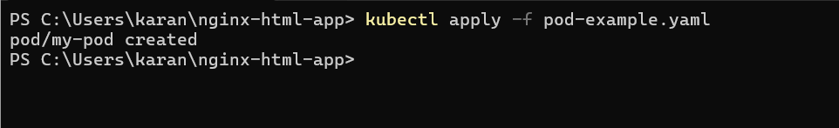

**Step 3: Verify the Pod Creation**

To check the status of the Pod and ensure it's running, use:

kubectl get pods

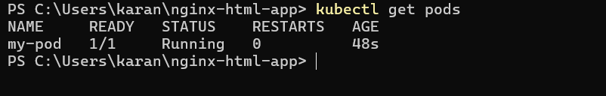

This command lists all the Pods in the current namespace, showing their status, restart count, and other details.

You can get detailed information about the Pod using:

kubectl describe pod my-pod

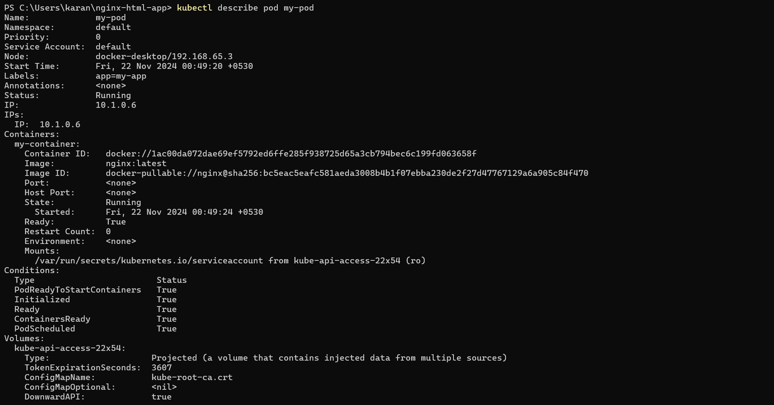

This command provides detailed information about the Pod, including its events, container specifications, and resource usage.

**Step 4: Interact with the Pod**

You can interact with the running Pod in various ways, such as accessing the logs or executing commands inside the container.

**View Logs: To view the logs of the container in the Pod:**

kubectl logs my-pod

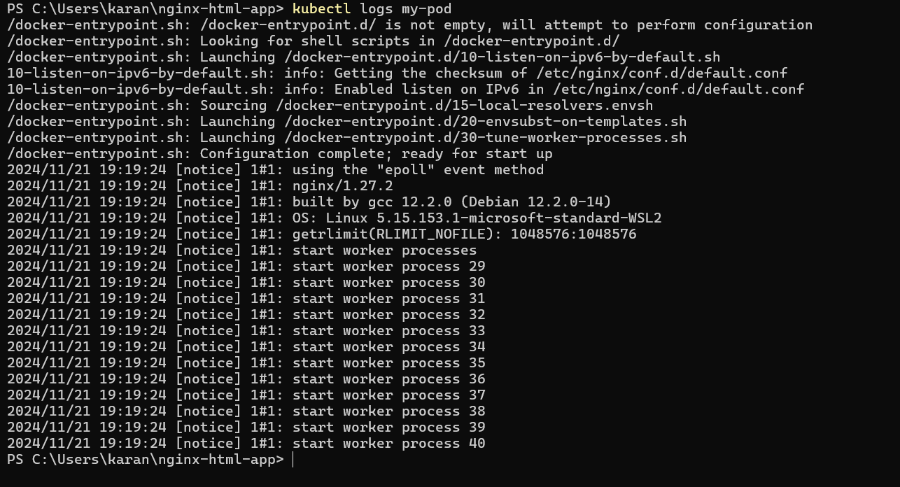

**Execute a Command: To run a command inside the container:**

kubectl exec -it my-pod -- /bin/bash



The -it flag opens an interactive terminal session inside the container, allowing you to run commands.

**Step 5: Delete the Pod**

To clean up and remove the Pod when you're done, use the following command:

kubectl delete pod my-pod

This command deletes the specified Pod from the cluster.

